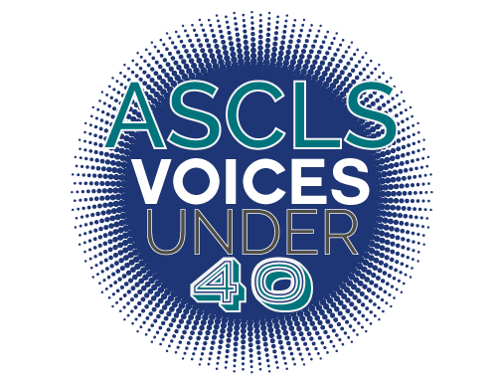
ASCLS VOICES UNDER 40 Deadline: April 1st

Application:

The ASCLS Voices Under 40 Spotlight has been developed to honor ASCLS members who have shown exceptional commitment to ASCLS, the laboratory profession, and their community at large at a young age in their professional career.

Requirements:
- Must be less than 40 years old as of January 1st of the year it is being awarded (awarded in June/July)
- Must complete application with a minimum accumulation of 30 points in the following areas:
  - Commitment to Advancing our Profession through Leadership
  - Commitment to Advancing our Profession through Education
  - Commitment to Promoting our Profession to the Public
  - Community Involvement

- Must submit Personal Statement
    - Answer all listed questions in your response.
    - Limit responses to 1-2 pages, double-spaced, 12-point font.
Timeline:
- March 1st, deadline for nominations submitted at https://ascls.org/voices-under-40-submission/
- Nominees will be contacted to confirm acceptance after the nomination deadline.
- Nominees submit their completed nominations form to ASCLS Membership Committee.
- Honorees recognized at Joint Annual Meeting
- Beginning in August, monthly spotlights on recipients are included on the website and in Society News Now.
Nominee
Name, Degree, Certification, and Title
→
Job Title
→
Employer
→
Work Address
→
City  → |  | State  → | Zip  →
Work email  → | Work Phone  →
Date of birth:
Home Address
→
City  → |  | State  → | Zip  →
Home email  → | Home phone  →

Commitment to Advancing our Profession through Leadership

Leadership within ASCLS: Elected and Appointed positions, including committees and task forces at any level of ASCLS.
Do not include scientific assembly or forum membership unless you are an active leader in said SA or forum.

List officer, board member or committee member positions at any level of ASCLS below.
(2 points for each year of service) MAX OF 20 POINTS Total:________

Leadership in other professional organizations
List organization, position and year(s) of term. NOTE that “member” in a professional organization does not qualify as evidence of “leadership” also local societies of ASCLS are included in preceding categories.
Examples of societies: AACC, AABB, ASM, CLMA, ASM, ASCP

List position title, activity, organization, and year below.
(1 point for each year of service) MAX OF 20 POINTS Total:________

Leadership through volunteering on other professional committees or boards, or leadership above and beyond your specific role at your workplace.
List organization, position and year(s) of term.

List position title, activity, organization, and year below.
(1 point for each year of service) MAX OF 10 POINTS Total:________

Commitment to Advancing our Profession through Education

Professional Presentations, Posters and Publications at scientific meetings or events.

List title, sponsor publisher or journal, dates, and hours.
(1 point for each) MAX OF 20 POINTS Total:________

Commitment to Promoting our Profession to the Public

Public Relations and Professional Legislative Advocacy
Presentations or volunteer efforts that focus on promoting the laboratory to non-laboratorians-ie blood drives, career fairs, letters to or meetings with senators and representatives, coordination of proclamation of Lab Week at any level of government.

List activity and year below
(1 point for each) MAX OF 20 POINTS Total:________

Community Involvement

Leadership in Church, Community or Civic Organizations
List organization, position and year(s) of term. NOTE that “member” in such groups does not qualify as evidence of “leadership”.

List title, activity, organization and year below
(1 point for each) MAX OF 10 POINTS Total:________

What are your current job responsibilities?

Please briefly answer the following questions. Limit your total response to 1-2 pages double-spaced, 12 pt font (MAX 9 points):
Judging Criteria (scored as an average of all judges scoring):
- Does the nominee directly address each question and give specific, complete answers?
- Does the nominee use correct grammar and spelling?
Scoring:
3-Question was answered exemplary. It was informative, well-organized and had little to no grammatical errors.
2-Question was somewhat informative and well-organized. Few grammatical errors were noted.
1-Question offered little to no information nor was well-organized. Several grammatical errors were noted.

Question 1: In your opinion, what is your best personal accomplishment within ASCLS (at any level)?

Question 2: What is your motivation for being actively involved in ASCLS (at any level)?

Question 3: What is your proudest achievement outside of ASCLS?

