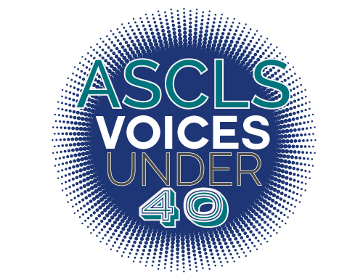
ASCLS VOICES UNDER 40 Deadline: April 1st

Application:

The ASCLS Voices Under 40 Spotlight has been developed to honor ASCLS members who have shown exceptional commitment to ASCLS, the laboratory profession, and their community at large at a young age in their professional career.

Requirements:
- Must be less than 40 years old as of January 1st 2022.
- Must complete application with a minimum accumulation of 30 points in the following areas:
  - Commitment to Advancing our Profession through Leadership
  - Commitment to Advancing our Profession through Education
  - Commitment to Promoting our Profession to the Public
  - Community Involvement
  - Leadership within the Workplace
- Must submit Personal Statement
    - Answer all listed questions in your response.
    - Limit responses to 1-2 pages, double-spaced, 12-point font.
Timeline:
- April 1st, completed applications due to ASCLS Membership Committee. Please submit email completed applications to andreah@ascls.org
- Honorees recognized at Annual Meeting
- July 1st, beginning of monthly spotlights
Nominee
Name, Degree, Certification, and Title
→
Job Title
→
Employer
→
Work Address
→
City  → |  | State  → | Zip  →
Work email  → | Work Phone  →
Date of birth:
Home Address
→
City  → |  | State  → | Zip  →
Home email  → | Home phone  →

Commitment to Advancing our Profession through Leadership

Leadership within ASCLS: Elected and Appointed positions (include all levels of involvement) eg. Committee (including convention planning or CE event planning)/Task Force/Liaison/Leadership Academy Graduate (National, Regional, or State)
Do not include scientific assembly or forum membership unless you are an active leader in said SA or forum.
List position and year(s) of term. List all years, adding an additional page if necessary. Indicate if chair, member.

National ASCLS officer, board member or committee member (2 points for each year of service) | Points
1
2
3
4
5
6
7
8
9
10
Regional ASCLS officer, board member or committee member (2 points for each year of service)
1
2
3
4
5
6
7
8
9
10
State/District/Local ASCLS officer, board member or committee member (2 points for each year of service)
1
2
3
4
5
6
7
8
9
10
Total points for elected leadership within ASCLS (MAX 20)

Leadership in other professional organizations
List organization, position and year(s) of term. NOTE that “member” in a professional organization does not qualify as evidence of “leadership” also local societies of ASCLS are included in preceding categories.
Examples of societies: AACC, AABB, ASM, CLMA, ASM, ASCP
Provide position title, activity, organization, and year (1 point for each year of service) | Points
1
2
3
4
5
6
7
8
9
10
Total points for leadership in organizations other than ASCLS (maximum 10 points)

Leadership on other professional committees or boards
List organization, position and year(s) of term. NOTE: only include those committees that go above and beyond your job responsibilities, exclude those that are required as a part of your job.
Examples: CLS Advisory Board for a College or University
Provide position title, activity, organization, and year (1 point for each year of service) | Points
1
2
3
4
5
6
7
8
9
10
Total points for leadership on professional committees/boards in organizations other than ASCLS (maximum 10 points)

Commitment to Advancing our Profession through Education

Professional Presentations
Platform presentations or posters at scientific meetings; provide title, sponsor, dates, and hours.
List Activity, Year, and Title(1 point for each presentation) | Points
1
2
3
4
5
6
7
8
9
10
Total professional presentations (maximum 10 points)

Professional Publications
Articles, editorials, professional books, book chapters. Give title, publisher or journal, year.
List Activity, Year, and Title (1 point for each publication) | Points
1
2
3
4
5
6
7
8
9
10
Total professional publications (maximum 10 points)

Commitment to Promoting our Profession to the Public

Public Relations
Presentations to church or civic groups, schools, National Medical Laboratory Professionals Week leadership, judging science fairs, assisting in clinics or blood drives.
Public relations activities, list activity and year (1 point for each activity) | Points
1
2
3
4
5
6
7
8
9
10
Total public relations activities (maximum 10 points)
Professional Legislative Advocacy
Letters to senators and representatives, meetings with senators and representatives, coordination of proclamation of Lab Week at any level of government.

List professional legislative activity and year (1 point for each activity) | Points
1
2
3
4
5
6
7
8
9
10
Total professional legislative activity and year (maximum 10 points)

Community Involvement

Leadership in Church, Community or Civic Organizations
List organization, position and year(s) of term. NOTE that “member” in such groups does not qualify as evidence of “leadership”. Your documentation must show an active role to be considered. Do not include participation in activities required by employer.
Provide title, activity, organization, and year(1 point for each year) | Points
1
2
3
4
5
6
7
8
9
10
Total church, community, or civic organizations leadership (maximum 10 points)

Leadership Within the Workplace

Leadership Above and Beyond Your Specific Role
List special workplace project/initiatives you have lead in the workplace, leadership activities above and beyond your job title, and outreach activities beyond your department. NOTE that “member” in such groups does not qualify as evidence of “leadership”. Your documentation must show an active role to be considered. Do not include participation in activities required by employer.

Provide title, activity, organization, and year(1 point for each year) | Points
1
2
3
4
5
6
7
8
9
10
Total Work Place Leadership (maximum 5 points)
Professional Reference Letter: Please provide 1 professional reference that we may contact for a letter of recommendation. (3 points)

Name
→
Email address
→
Personal Statement (Questions 1-3 are worth 3 points MAX each)
Please answer the following questions. Limit your total response to no more than 2 pages double-spaced, 12 pt font:
- In your opinion, what is your best personal accomplishment within ASCLS (at any level)?
- What is your motivation for being actively involved in ASCLS (at any level)?
- What is your proudest achievement outside of ASCLS?
- What are your current job responsibilities?

